We are pleased to announce the establishment of the Metropolitan New York Ski Council’s Harry Walter Voege Scholarship Program to honor and thank Harry for six decades of commitment and generosity as a valued member of the MNYSC. Harry lived by the creed of promoting the friendly sport of skiing, bringing together persons interested in skiing, and making it easier for members of the clubs to participate in skiing. We hope to extend Harry’s passion through this Memorial.

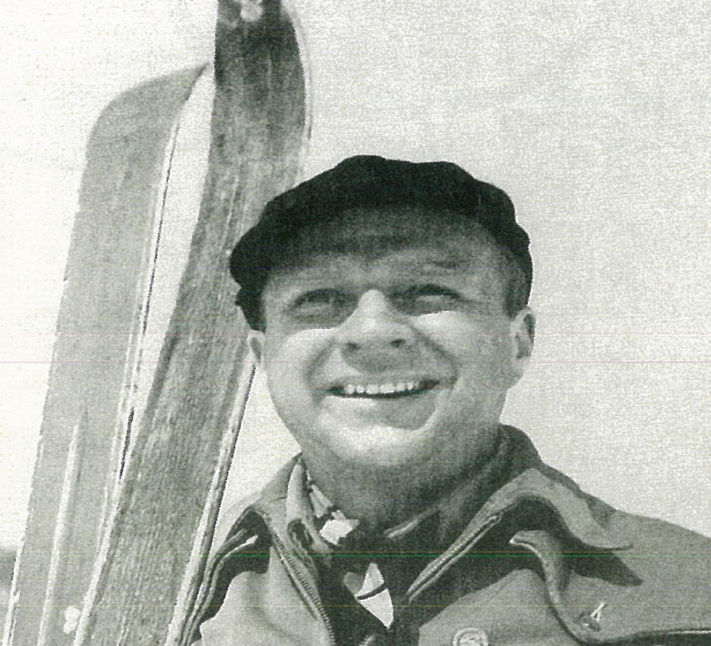
Harry Walter Voege (1912 – 2002)
The first snowflake beckons
I’m drawn like a moth to a flame
I find myself running
I feel the need to ski…I must ski!
There is no escape from my addiction
It’s what sets me free…that first snowflake… (a.voglio)

The Man
In his lifetime, Harry Walter Voege, an early member of the National Ski Patrol, made immeasurable contributions to the NSP as well as the individual patrols and organizations he served. He was an honorary life member and founding father of the Garden City Ski Club, Garden City, New York. A businessman, entrepreneur, and investor by trade, Voege lived to ski. His world revolved around skiing. He loved skiing with a passion. Because of his love of skiing, Harry bequeathed a substantial amount of money to the NSP, which ill allow the continuation of education programs and development and quality assurance programs in skier and rider safety awareness.

Thank you Harry for all that you have done for the sport of skiing. May your slopes always have a little powder on them.
Although the prerequisites for applying call for the applications to be members of the MNYSC for two seasons (either as a single member or part of a family membership), there shall be a relaxing of that prerequisite for the years 2015-2016 scholarship award as follows:
- For all award years the applicant must have a parent or grandparent who has been a member of the current and past season with no requirement that the applicant be a member.

Who is eligible to apply?
Applicant must be a current MNYSC family member or an individual member pursuing post-secondary education and have been a member the prior season as well. Awards take into account many factors including financial need, academic achievement, extra curricular activities, community service and character.

How does the process work?
Using an objective scoring system, the Committee reviews the numbered applications and votes to determine the recipient of the award. Unless otherwise specified, the scholarship is for one (1) year, non-renewable, and must be used in the academic year for which it is awarded. Decisions are announced in June.

When are applications due?
The applications must be post-marked by April 15th. Late applications will not be accepted.
Application Instructions
- Print or type all requested information.
- Complete all items to ensure that your application can be assessed fairly. If you are not sure which school you will be attending, submit information for your first choice. If you have additional questions, or if information changes after you have submitted your application, you should notify Michael Calderone by phone at (917) 217-8314 or by Email at skimikec@aol.com
- To avoid disqualification, please review your application before submitting it to be sure that you have properly completed all items on each page and attached all necessary documentation.
- Be sure that both applicant and parent/guardian have signed the certification statement at the bottom of page 1 of the application. Parent/guardian signature is required for all applicants, except those who are independent and are no longer claimed as a dependent by parent(s)/guardian(s) on their Federal Income Tax.
- Attach a copy of your transcript through the first semester of the current school year.
- For your records, detach this cover sheet and keep it along with a copy of your completed application.
- Submit applications in a sealed envelope to Harry Walter Voege Memorial Scholarship, c/o Metropolitan New York Ski Council, 1019 Fort Solonga Road, Suite 10 # 235, Northport, NY 11768. Late applicants will not be accepted. You may include a self-addressed, stamped postcard if you would like us to verify receipt of your application. All applications must be post-marked by April 15th.

The Harry Walter Voege Memorial Scholarship does not discriminate against applicants on the basis of race, creed, color, national origin, ancestry, sex, disability, sexual orientation, or income. The MNYSC preserves and protects the confidentiality of all information received on the application and will release it only on a need to know basis.
FREQUENTLY ASKED QUESTIONS

- When are applications due?
Applications must be post-marked by April 15th. Applications must be postmarked or dropped off on or before the due date. You may mail your application to:

Harry Walter Voege Memorial Scholarship
c/o Metropolitan New York Ski Council
1019 Fort Solonga Road,
Suite 10 # 235,
Northport, NY 11768

- What happens if an application is late?
Late applications are not accepted. We encourage you to send in your application as soon as it is completed.

- How is my privacy protected?
We take applicant’s privacy seriously. Upon receipt, each application is checked for completeness and assigned a number by the chairperson of the Application Review Committee. The first page, containing identifying information, is then removed to preserve confidentiality. The subcommittee then begins to review the numbered applications.

- Who can apply?
Applicant must be a current MNYSC family member or an individual member pursuing post-secondary education and have been a member the prior season as well.

- What is the basis for awarding scholarships?
The MNYSC takes into account academic achievement, extra curricular activities, community services, character and financial need.

- Is there a limit on the number or amount of scholarships you will award to one family?
No. There is no maximum for the number of family members who can receive a scholarship or the amount awarded to any particular student or family.

- Can I reapply?
Yes. You may apply for a scholarship each year throughout your college/school career.

- If I receive a scholarship am I guaranteed to receive one the following year?
No, you must reapply each year. Keep in mind our applicant pool changes from year to year as does the amount of funds available. You may receive an award as a graduating high school senior, not receive one as a college freshman, but then receive an award again as a sophomore or junior.

- What if my college/school changes?
Notify Michael Calderone by phone at (917) 217-8314 if you change your school choice. If your scholarship has already been paid, your school may return the award to the MNYSC. If this happens, we can send the award to your new school if the change occurs within the same school year and you complete the MNYSC form for payment.
SCHOLARSHIP APPLICATION CHECKLIST

Incomplete and/or late applications will not be considered. Before submitting your application, make sure you have completed all of the following:

Completely and neatly filled out all four pages of the application;

Applicant and parent/guardian have signed the Certification Statement;

Essay is enclosed with application;

Official transcript is attached to the application or is being mailed directly to Harry Walter Voege Memorial Scholarship, c/o Metropolitan New York Ski Council, 1019 Fort Solonga Road, Suite 10 # 235, Northport, NY 11768. (must be post-marked by April 15th). (Please note: if your final semester grades will not be processed/available by the deadline, we will accept an official transcript of your most current semester grades.)

Two Recommendation Forms are attached to the application or are being mailed directly to:

Harry Walter Voege Memorial Scholarship
c/o Metropolitan New York Ski Council
1019 Fort Solonga Road,
Suite 10 # 235,
Northport, NY 11768

All applications and/or recommendations must be post-marked by April 15th.
General Information

1. | Name: | _____________________________________________________________________
 | Telephone: | _______________________________ Cell:_________________________________
2. | Home Address: | _____________________________________________________________________
3. | Email: | ______________________________________________________________________
4. | MNYSC Ski Club Affiliation:____________________________________________________________
5. | Number of years in the Metro New York Ski Council:__________________________________
6. | Name of College/School:_____________________________________________________________
7. | Location of College/School:___________________________________________________________  City State
8. | Major/Area of Study/Interest:_______________________________________________________
9. | Intended/required length of study (in years): _________ Intended year of completion:______
10. | For the Upcoming school, will you be an: ( ) Undergraduate ( ) Graduate Student
11. | For the Upcoming school, will you be a: ( ) Full-time Student ( ) Part-time Student

Certification Statement

To the best of my knowledge the information contained in this application is true and correct. I have read the Application Information and Instructions cover sheet and understand that I am responsible for the submission of all information and documentation required by the April 15th post-marked deadline. Late applications will not be accepted. The Metropolitan New York Ski Council reserves the right to disqualify incomplete applications.

____________________________________  Applicant Name (Please print) | ___________________________________  Applicant Signature | ______________  Date
____________________________________  Parent/Guardian Name (Please print) | ___________________________________  Parent/Guardian Signature | ______________  Date

Parent/guardian signature is required for all applicants except those who are independent and are no longer claimed as a dependent by parent(s)/guardian(s) on their Federal Income Tax.
FAMILY INFORMATION

- Including yourself, list the ages of dependent children in the household. Do not include names (e.g., 20, 18, 14, 10): ____________________

- Including yourself, how many of the above will be attending post-secondary institution during the coming school year? (e.g., 1, 2, 3): _____________

ACADEMIC INFORMATION

- Please provide the following: High School GPA:__________ High School Class Rank:__________

Number of Students in High School Class: _________ Year of High School Graduation:______

- Please submit a copy of your High School transcript.

- If presently attending College:

  - Total number of credit hours required for graduation: ____________________
  - Number of semesters completed prior to the current semester: ____________
  - Cumulative GPA (please note if base is other than 4.0):____________________
Please attach a copy of your transcript through the first semester of the current school year.
  - Based on the current semester, enter the number of hours for the following:
    - How many hours per week are you in class? ________________
(ex.: 5 classes at 3 hours per week plus one lab of one hour per week=16)
    - a. If you have a job during the school year, how many hours per week do you work? ________________
b. How many of these hours are considered Work Study as part of your financial aid package? _____________

SUPPLEMENTARY INFORMATION

- Please specify schools you are a graduate of:____________________________________________
- Graduate Students only:
Undergraduate Degree: _____________ from: ____________________________year:____________
- Write a brief statement of your career interests and objectives.
_________________________________________________________________________________________________________________________________________________________________________________________________________________________________________________________________________________
SCHOOL, COMMUNITY, ACTIVITIES AND WORK

- List extracurricular activities, including academic/honor societies, and offices held, during your four high school years and, if applicable, during college (e.g., Soccer, 2, 3,4, Capt. 4; French Club, 1, 2, 3, 4, Sect. 3). If you attach a resume, please remove your name.
_________________________________________________________________________________________________________________________________________________________________________________________________________________________________________________________________________________
___________________________________________________________________________________________
___________________________________________________________________________________________
___________________________________________________________________________________________
- List volunteer /unpaid services and activities in the community other than those related to school athletics and clubs.
_________________________________________________________________________________________________________________________________________________________________________________________________________________________________________________________________________________
___________________________________________________________________________________________
___________________________________________________________________________________________

___________________________________________________________________________________________

3. Do you work or have your worked during the previous 12 months? ( ) Yes ( ) No Include Employer, Position/Type of Work, Dates of Employment, Hours worked per week:

_________________________________________________________________________________________________________________________________________________________________________________________________________________________________________________________________________________
___________________________________________________________________________________________
___________________________________________________________________________________________

__________________________________________________________________________________________
4. Please list any special circumstances which you feel would be useful to the Committee in evaluating your application, including financial considerations. If none, leave blank.

_________________________________________________________________________________________________________________________________________________________________________________________________________________________________________________________________________________
___________________________________________________________________________________________
___________________________________________________________________________________________

___________________________________________________________________________________________

5. Have you or your family members volunteered to help the club? ( ) Yes ( ) No

6. If you receive a scholarship, will you share some information about yourself, your academic goals, and career objectives in your thank you note to the Committee? ( ) Yes ( ) No

Please remember to review and sign your application and attach all
Necessary documentation.

ESSAY GUIDELINES

 | All applicants must submit an essay to be eligible for a scholarship
 | Answer the following question: How has skiing, snowboarding, or other winter sports affected your life?
 | The other requirements for the essay are as follows:  - Essay must be typed and double spaced  - Length: Minimum – one page  Maximum – two pages

Harry Walter Voege Memorial Scholarship
c/o Metropolitan New York Ski Council
1019 Fort Solonga Road,
Suite 10 # 235,
Northport, NY 11768

TRANSCRIPT REQUEST

_____________________________________ ______________________________________
Applicant’s Name (Please print) Applicant’s Signature

_________________________________________________________________________________
Applicant’s Address

SCHOOL RECORDS OFFICE:

The above named individual is applying for the Metropolitan New York Ski Council Harry Walter Voege Memorial Scholarship. In order to process his/her application, we need to have an official copy of his/her complete transcript. We also need the results of any tests (i.e., SAT/LSAT/GMAT/GRE) which the candidate has taken. The information is to be held in confidence and we thank you for your assistance.

SCHOLARSHIP APPLICATION MUST BE
POST-MARKED BY APRIL 15th

Harry Walter Voege Memorial Scholarship
c/o Metropolitan New York Ski Council
1019 Fort Solonga Road,
Suite 10 # 235,
Northport, NY 11768

RECOMMENDATION FORM

______________________________________________________________
Student’s Name

______________________________________________________________
School Attending

The above named individual is applying for the Metropolitan New York Ski Council Harry Walter Voege Memorial Scholarship. In order to aid the Scholarship Committee in making their very difficult selection, we would appreciate your assistance in completing the attached Recommendation form. All forms must be post-marked by April 15th.

SCHOLARSHIP APPLICATION MUST BE
POST-MARKED BY APRIL 15th

RECOMMENDATION FORM

- What do you know of this student’s intellectual qualities? We are especially interested in any evidence you can give about the nature of his/her motivation for academic work, the originality, independence and sensitivity that he/she displays in course work and the quality of performance as compared to that of classmates. For instance, is this student self-directed or driven by pressures from family or from status? Is this student studying for his/her own satisfaction or for grades? Does this student pursue studies beyond assignments or does he/she have to be prodded?

________________________________________________________________________________________________________________________________________________________________________________________________________________________________________________________________________________________________________________
____________________________________________________________________________
____________________________________________________________________________
- How would you judge the use that this student makes of his/her time? For instance, does he/she participate in any extracurricular community or creative activities?

________________________________________________________________________________________________________________________________________________________________________________________________________________________________________________________________________________________________________________
____________________________________________________________________________
- Is he/she a productive leader, a helpful follower or a “joiner”? Please explain.
________________________________________________________________________________________________________________________________________________________________________________________________________________________________________________________________________________________________________________
____________________________________________________________________________
- What are your impressions of this student’s character, aims and values?

____________________________________________________________________________
____________________________________________________________________________________________________________________________________________________________________________________________________________________________________
- What are the first few words that come to mind to describe this student’s personality?

____________________________________________________________________________
____________________________________________________________________________________________________________________________________________________________________________________________________________________________________
- How long have you known this student?
____________________________________________________________________________
____________________________________________________________________________
- Please add any additional comments that you feel will be importance to the Committee:

____________________________________________________________________________
____________________________________________________________________________________________________________________________________________________________________________________________________________________________________
PLEAS RETURN TO:
Harry Walter Voege Memorial Scholarship
c/o Metropolitan New York Ski Council
1019 Fort Solonga Road,
Suite 10 # 235,
Northport, NY 11768

SCHOLARSHIP APPLICATION MUST BE
POST-MARKED BY APRIL 15th

